**COMPUTER NETWORKS - CSA07**

**Parthibhan .R**

**192224275**

**EXPRIMENT 2:-**

Configuration of Topologies using Packet Tracer (Star, Mesh, Tree,)

GithubLink:-https://github.com/parthibhan007/CSA0748-computer-network/tree/main/expriment%202

**1.Star Topology:-**

**Simulation:-**

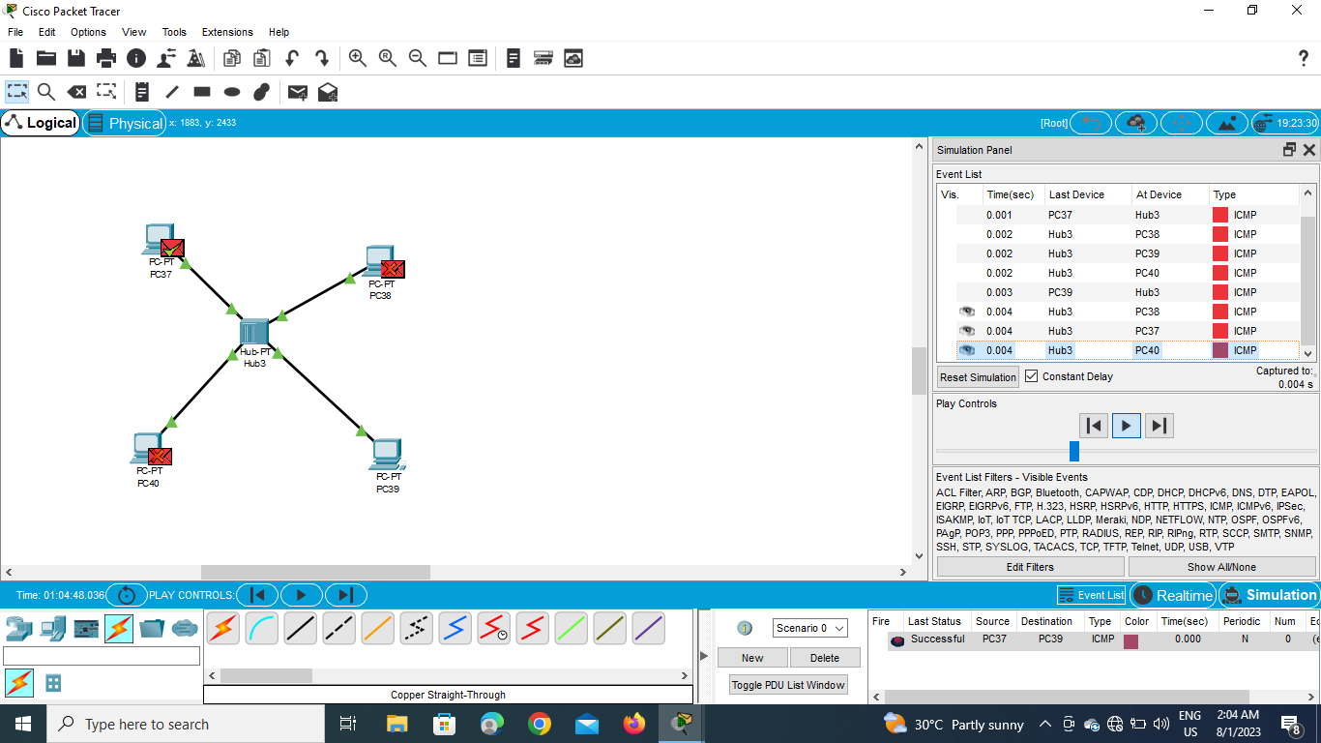

**Real Time :-**

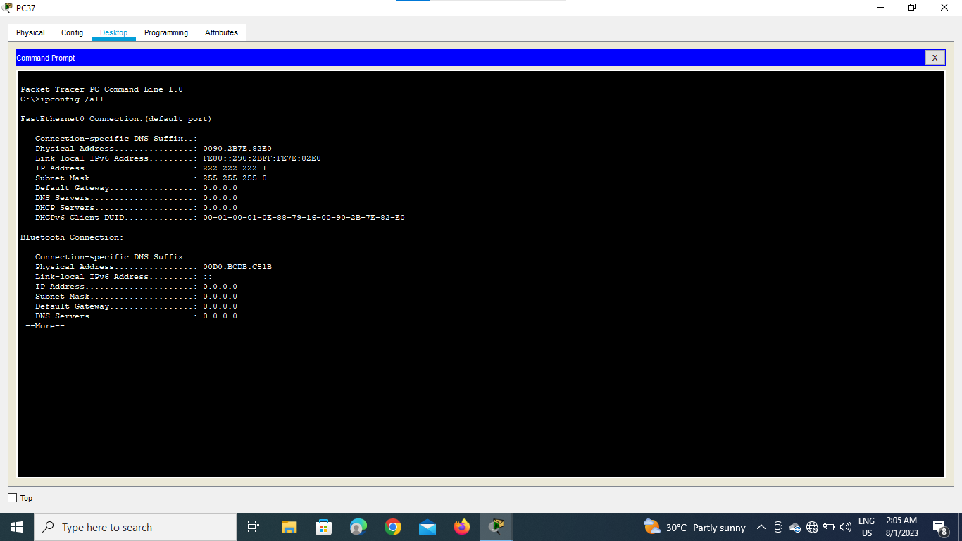

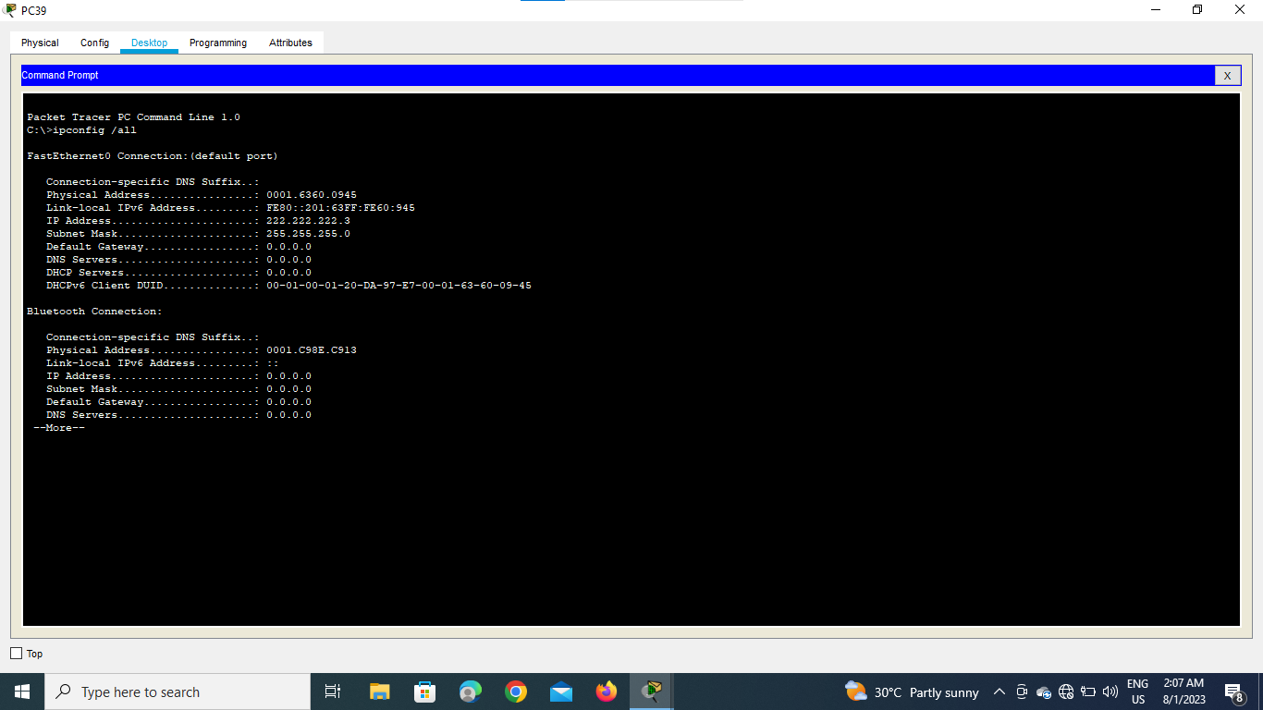

**2.Mesh Topology:-**

**Simulation:-**

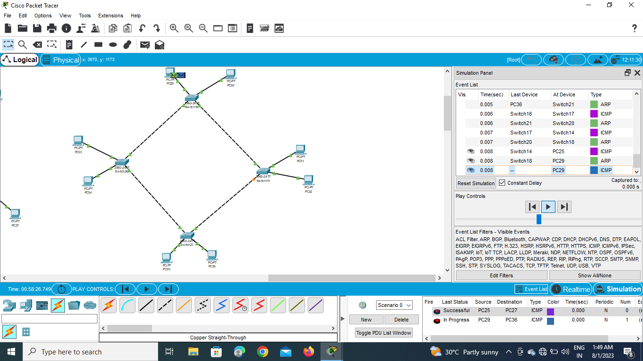

**Real Time :-**

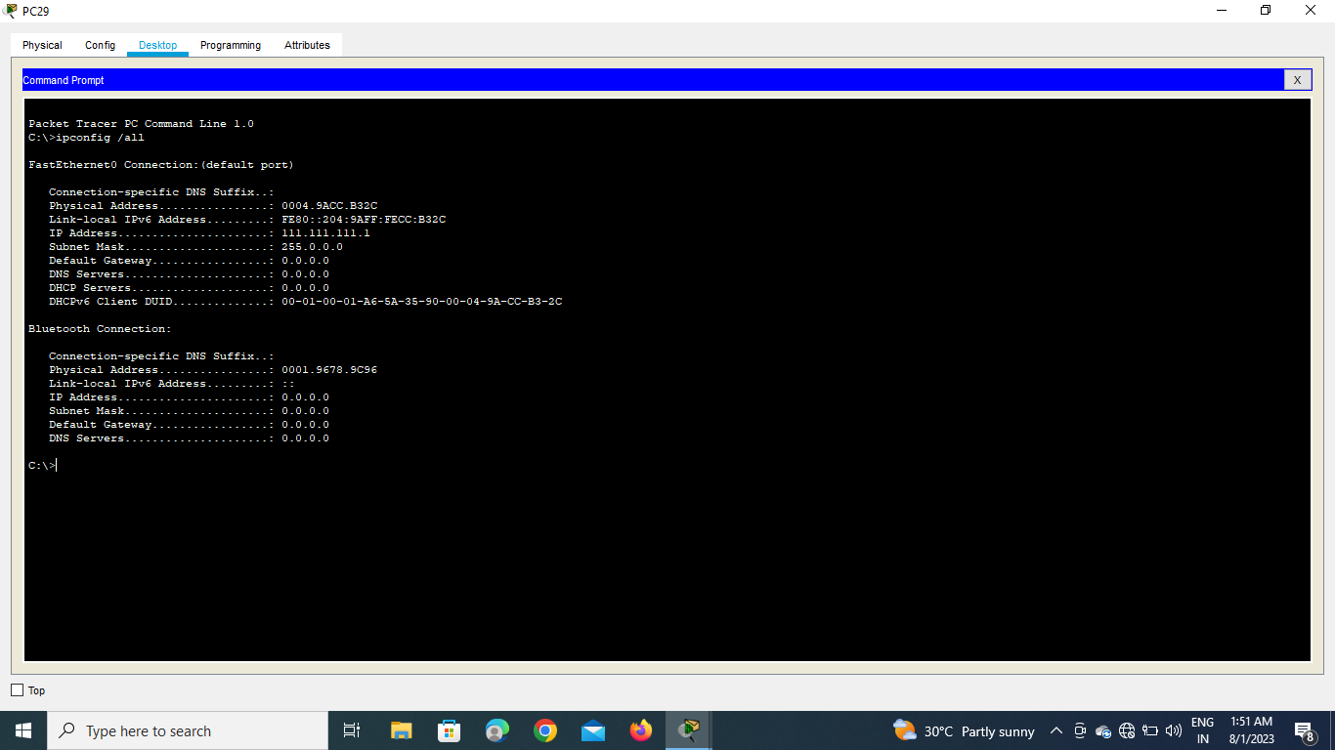

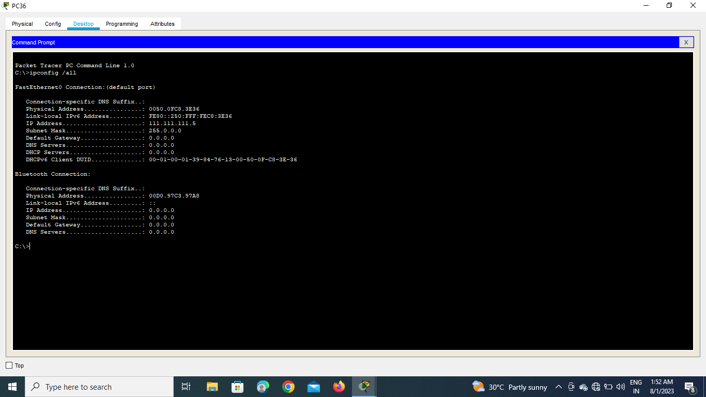

**3.Tree Topology:-**

**Simulation:-**

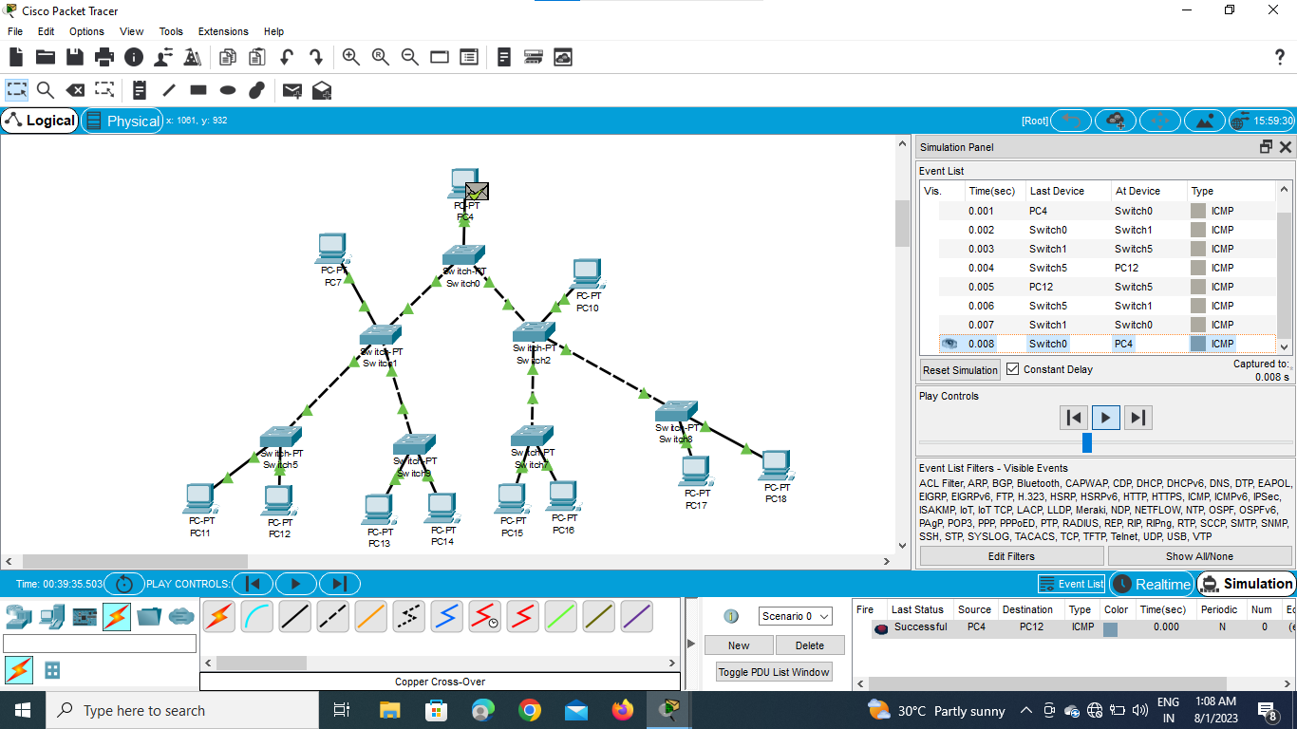

**Real Time :-**

